Job Description and Personal Specification

Job Title | Oncology Health Play Specialist – Bristol Royal Hospital for Children
Line Manager | Play Services Manager and Grand Appeal Deputy Director
Location | Bristol Royal Hospital for Children, BS2
Terms | Permanent/Full-Time 37.5 hours per week
Salary Range | £28,000 - £32,000 (DOE)

The Grand Appeal
Wallace & Gromit’s Grand Appeal works in partnership with Aardman to support Bristol Children’s Hospital and the Neonatal Intensive Care Unit (NICU) at St Michael’s Hospital. For 31 years, The Grand Appeal has been at the forefront of children’s healthcare transforming facilities at Bristol Children’s Hospital and NICU and driving progress by uniting philanthropy with world-class medicine to save lives and improve childhood health.

The Grand Appeal’s support spans pioneering medical equipment, life-saving technology, world-leading research and cutting-edge innovation to elevate the care and treatment of babies and children from throughout the Southwest region. From advanced imaging and surgical robotics to pioneering developments in childhood health, our funding helps expert clinicians save more lives and shape the future of childhood health. Our long-standing partnership with Aardman is the foundation on which The Grand Appeal is built.

The Role
Supporting the Play team provision in the children’s hospital is a core part of The Grand Appeal’s activity. The Oncology Health Play Specialist role works within the Play Department to implement safe, high quality play programmes covering all aspects of hospital play provision which meet patient’s emotional, social, developmental, and creative needs.

The Oncology Health Play Specialist will respond to referrals from the multidisciplinary team to provide support for children and young people on the Starlight (oncology) ward at Bristol Royal Hospital for Children (BRHC), through play preparation and play plans. The role holder will support oncology patients through procedures using therapeutic play and distraction therapies, working alongside the Health Playworker to prioritise patient’s needs. The specialist will also supervise students, volunteers, visitors and entertainers throughout the hospital.

This post is employed and funded by The Grand Appeal with an honorary contract with The Bristol NHS Group Foundation Trust and line management from the Senior Health Play Specialist at BRHC. The post holder is therefore required to adhere to and align with the standards and values of each of The Grand Appeal and the Trust.

What we offer:

The Grand Appeal is the employer. This role offers a dynamic, supportive, and rewarding workplace for its approx. 45 staff. We have a strong team culture in which all our staff play an important part. Our staff are talented, creative, ambitious and The Grand Appeal’s most important resource.

- Competitive salary
- Generous holiday allowance
- Healthcare plan (after probation)
- Pension scheme (including salary sacrifice)

If this sounds like the right workplace for you, you have the required skills and experience, and you are looking for a new challenge, we would love to hear from you.

How to apply:

To apply, send your completed application form and a copy of your CV to jobs@grandappeal.org.uk.

The closing date for applications for this role is 11.59pm on Friday 31st July.

For an informal discussion about the role, please contact Anna Shepherd on 0117 927 3888 or jobs@grandappeal.org.uk.

Key tasks and responsibilities include:

Job Purpose
- To implement safe, high quality play programmes covering all aspects of hospital play provision which meet patients emotional, social, developmental, and creative needs.
- To respond to referrals from the multidisciplinary team to provide support for children and young people on the oncology ward at Bristol Royal Hospital for Children (BRHC), through play preparation and play plans.
- To support oncology patients through procedures using therapeutic play and distraction therapies.
- To work alongside the Health Playworker to prioritise patient’s needs.
- The Health Play Specialist will work in partnership with the Health Play Worker, coordinating workloads as needed to support effective service delivery.
- To be involved in the development and maintenance of play preparation resources.
- Maintain high levels of patient confidentiality.

Communication
- To communicate appropriately with children / families and all members of the multidisciplinary team.
- Encourage and support parents to join in play and activity with their children / young people.
- Ensure that data is maintained in accordance with the Trust standards and policy.
- Attend staff meetings to share relevant information related to the Trust and the Play department.
- To supervise students, volunteers, visitors and entertainers throughout the hospital.

Personal and People Development
- Review and reflect on own practice and performance through appraisal.
- Keep records of training attended as part of Personal Development Plan and reflective practice.
- Maintain professional portfolio and re-registration.
- Participate in relevant internal and external learning opportunities.

Health and Safety
- Ensure that all children and young people in your care are supervised and escorted at all times.
- Ensure that toys are cleaned in line with the department’s infection control SOP.
- Ensure that toys and equipment are maintained in good, safe order and well stocked in consultation with the Play Department manager.
- Take responsibility for infection control related to play equipment and play activities.
- Incident reporting via the Trust process and feedback to appropriate staff.
- Identify and follow up safeguarding concerns for patients, families, and staff in line with Trust policy, maintaining all mandatory Trust training.

Service Improvement
- Meet with the Senior Health Play Specialist/line manager on a regular basis for supervision and to share information about team/department and Trust developments.
- Assess and prioritise play needs and referrals as directed by line manager and the play department manager.

Quality
- Work flexibly and individually across play speciality areas as requested by the play department manager or the line manager.
- Refer complex referrals to senior play specialists for support.
- Adhere to hospital and departmental policies and procedures.
- Make safe, economical and sustainable use of play equipment.

Professional Respect and Conduct
- Respect the individual backgrounds, beliefs, values and circumstances of patients and their families and contribute to the delivery of a service that is respectful and sensitive to their needs.

Organisational Structure within the Play Team at BRHC:

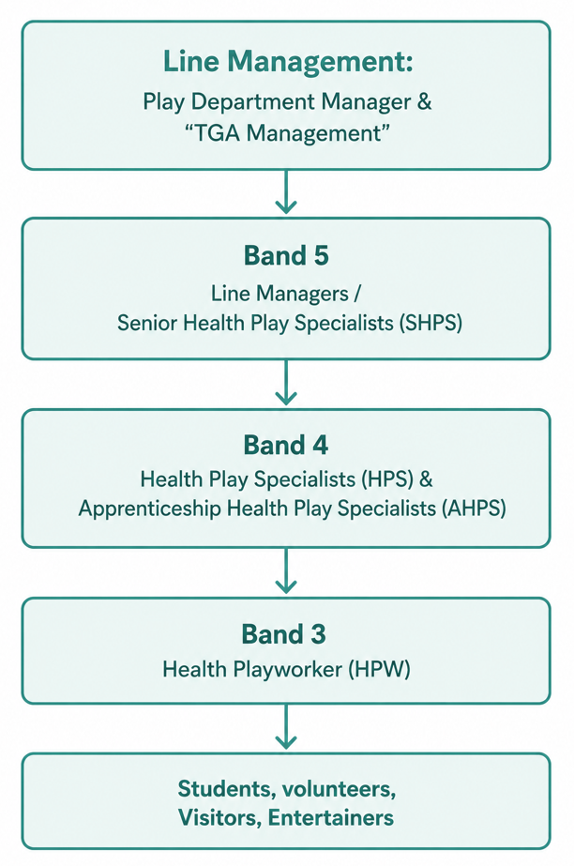

This role profile is not exhaustive and is subject to review in conjunction with the post holder and according to future changes/developments at BRHC and the Grand Appeal. All job descriptions are non-contractual and give a sense of the broad scope of the role and so include a level of flexibility. Whilst they list some key tasks, there will also always be tasks that arise, and which can be reasonably expected of the role.

The Grand Appeal is committed to safeguarding and promoting the welfare of all children, young people and vulnerable adults. As such, expects all staff and volunteers to share this commitment.

Personal specification
E = essential / D = desirable

Experience and knowledge
Importance | Criteria
E | Experience of working as a Health Play Specialist with children in a hospital setting
E | 2 years’ experience of working in a play/early years/education/youth work setting
E | Experience of assessing patients’ needs to provide specialised play, therapeutic distraction, preparation and post procedural play
E | Excellent knowledge of child development
D | Experience of working as part of a multi-disciplinary team and have ability to communicate effectively at all levels

Skills and abilities
Importance | Criteria
E | Excellent communication and interpersonal skills
E | Strong IT skills including use of Microsoft Word, Excel and other in-house systems
E | Problem solving and analytical skills
E | Excellent time management skills
E | Ability to work under own initiative and to motivate others
E | Ability to work under pressure and manage conflicting demands
E | Positive and motivated team player
E | Promotes positive working relationships with all colleagues within the play team and wider multi-disciplinary team
D | Awareness of budget and stock control

Other requirements / qualifications
Importance | Criteria
E | Foundation Degree (FdA) in Healthcare Play Specialism or equivalent
E | Current HPSET registration (or overseas equivalent) or be in the process of re-registering. You will be required to remain registered with HPSET (or overseas equivalent) whilst in post
E | Responsible for being up to date with, and adhering to, current UHBW practices, standards and values, as well as relevant legislation
E | Role model the UHBW Trust Values in all circumstances: supportive, innovative, respectful, collaborative
E | Willingness to reflect upon practice and be open to new ideas and ways of working
E | Enthusiastic and motivated to continually develop
E | Act as an ambassador and advocate for the Grand Appeal Charity
E | Attend relevant Grand Appeal events and support charity communications as required, with TOIL provided

